KAMALA INSTITUTE OF TECHNOLOGY & SCIENCE, SINGAPUR – 505 468
DEPARTMENT OF COMPUTER SCIENCE AND ENGINEERING

OTHERS INFORMATION REGARDING DEPARTMENT ACHIEVEMENTS

The department has established “ HELP HELPLESS “ as a part of social service in 2009.. It organizes events on important dates and helps the needful. The following are the activities done by the Department of Computer Science and Engineering under HELP HELPLESS.

- 1st Jan 2009
The department started “HELP HELPLESS” mission as a social welfare activity. On this day, the team volunteers and staff went to “MALLIKAMBA MANOVIKASA KENDRAM, HANAMKONDA (the school for mentally retarded students) “ and donated 30 fiber chairs, distributed fruits, cakes to the mentally handicapped children.
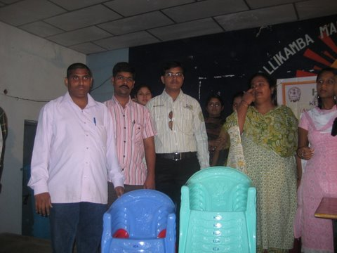
- 7th Jan 2009
With help of “NIRMAAN” organization department arranged “SWAMI VIVEKANANDA’S YUVA SANKALP” program, the member of that organization gave a speech on swami VIVEKANADA, distributed the VIVEKNANDA’s books to all the students of all the departments of the college.

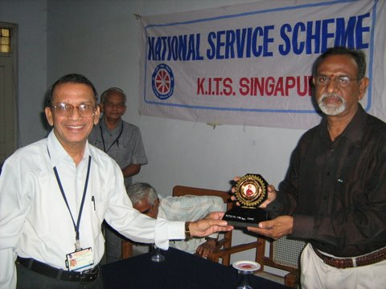
- 26th Jan 2009
“HELP HELPLESS” the team volunteers and staff went to “SPACE (orphanage for blind children) “and celebrated the Republic Day with blind children and distributed them fruits, chocolates and sweets.
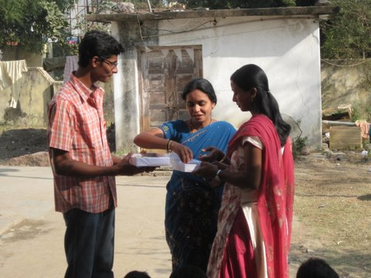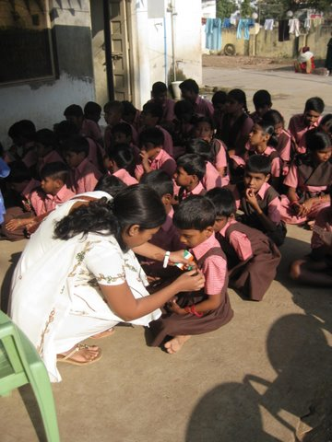
- 29th Jan 2009
Department arranged a seminar for the students who want to study in Canada. Uma Venkatraman, Director & Immigration Advisor, CSIC and Venky Subramaniam, Director-OSSS gave useful information about studies and opportunities in CANADA.
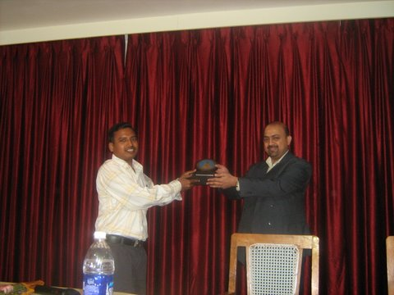
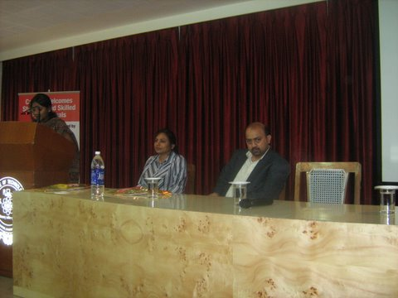
- 17th & 18th Feb 2009
Department arranged two day workshop on “SOFTWARE TESTING” for the students. Prof M.L.SAI KUMAR, IPE-INDIA gave the lecture.
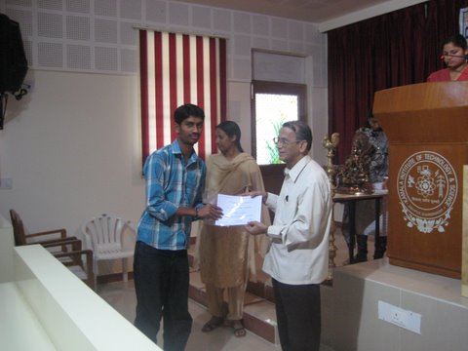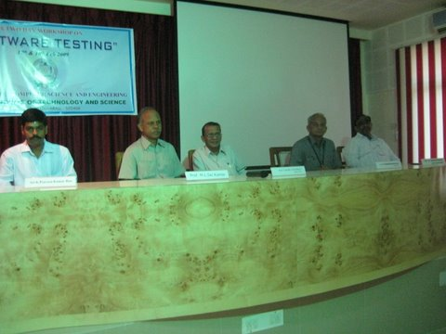
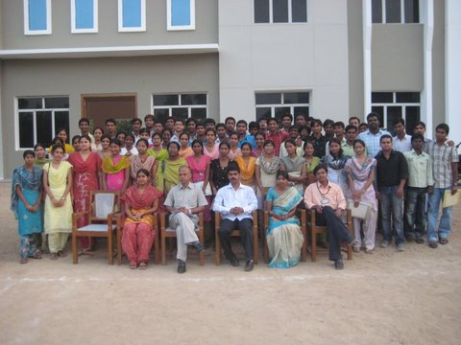
- 18th Feb 2009
M.L.SAI KUMAR, IPE-INDIA gave a seminar for the teaching faculty on the topic “Teaching Methodologies and techniques”.
- 6th & 7th Mar 2009
Department conducted a state level two day student technical festival “CloSurE - 09” for all the engineering students of all branches of all colleges. The various events organized were Papriez, Buzz Quiz, Dexter’s Lab, Fun with Mathematics, Brain Breaker, Blind Man’s Hunt, AdZap, Logo Designing, Poster Designing. The winner’s for the events are as follows.
Brain Breaker
1st Prize – Ch. Manasa – CSE ( KITS (S ))
2nd Prize- V. Sindhuja – CSE ( Ramappa Engineering College, Warangal)

Dexter’s Lab
1st Prize – B. Manasa – CSE ( KITS (S))
2nd Prize- K. Prashanth – IT ( KITS (S))
Fun with Mathematics
1st Prize – P. Avinash – CSE ( KITS (S))
2nd Prize – V.N.V.S Abhilash – ECE ( BIES, Narsampet )

Papreiez
1st Prize: Vishwaraj & S.Karthik ( JITS, Narsampet )
2nd prize: Abhinay Soma (JITS, Karimnagar )

Consolation:
1. Alekya Reddy G – IT ( KITS ( S ))
2. P. Sai Krishna & Adheebe Eram – ECE ( KITS ( S ))
3. T. Ravi & R. Mahesh – EEE (BIES, Narsampet )
4. Ajay Joshi – ME ( KITS ( S ))
5. M. Damodar & T. Sweetha – CSE ( Ramappa Engineering College, Warangal)

Ad-Zap
1st Prize: B. Karthik – CSE ( JITS, Narsampet )
2nd Prize : T. Vineela – CSE ( KITS ( S ))

Logo Designing
1st Prize: P. Sravani – ECE ( KITS ( S ))
2nd Prize : N. Harika – CSE ( KITS ( S ))

Blind Man’s Hunt
1st Prize: Md. Sajjid & K. Arun Kumar (JITS, Karimnagar )
2nd Prize: Madhav Sanathan & Neelima – IT ( KITS ( S ))

Poster Presentation
1st Prize: V. Naresh & S. Karthik – CSE ( JITS, Narsampet )
2nd Prize: Ajay Joshi – ME ( KITS ( S ))

- 15th Aug 2009
“HELP HELPLESS” the team volunteers and staff went to “OASIS ORPHANAGE “conducted games, sports to orphans and distributed prizes for winners, arranged Lunch to them and donated a Music system to orphanage.
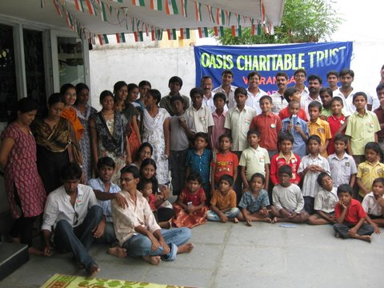
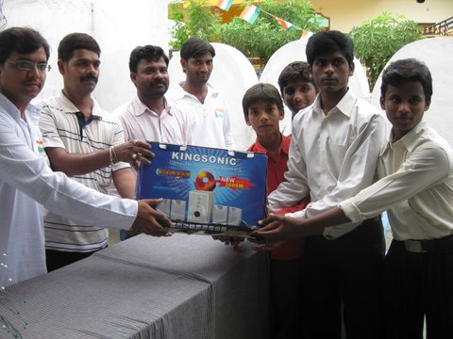
- 25th Aug 2009
Department arranged a blood camp with help of Red Cross Society. 200 units blood was collected.
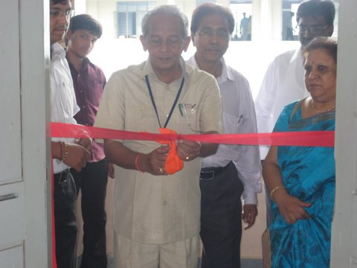

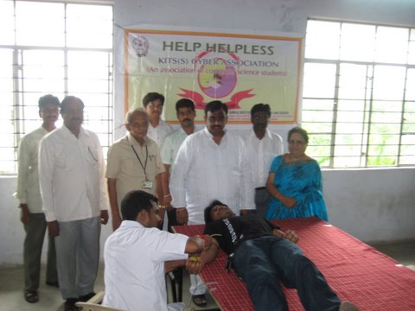
- 28th Aug 2009
“HELP HELPLESS” the team volunteers distributed “SWINE – FLU” prevention homeopathy medicine for free to all the students staff of our college.
The same medicine was freely distributed to MALLIKAMBA MANOVIKASA KENDRAM, OASIS ORPHANAGE and SPACE BLIND SCHOOL.

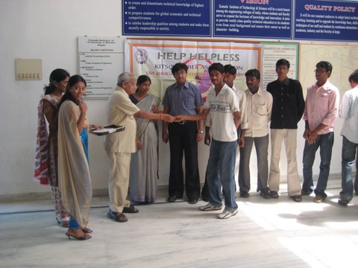
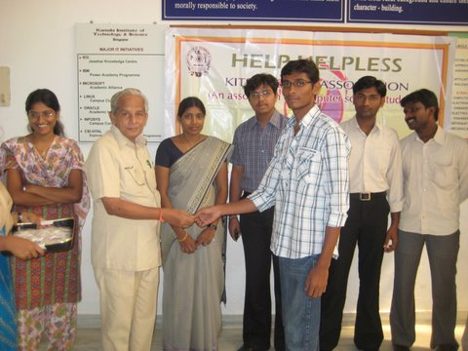
- 26th Jan 2010
“HELP HELPLESS” the team volunteers and staff went to “OASIS ORPHANAGE “conducted games, sports to orphans and distributed prizes for winners, arranged Lunch to them and donated 35 chairs & DVD Player to orphanage.
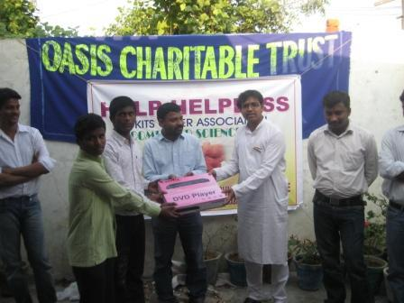

- 15th Aug 2010
“HELP HELPLESS” the team volunteers and staff went to “OASIS ORPHANAGE “conducted games, sports to orphans and distributed prizes for winners, arranged Lunch to them and donated school bags , books, pens, pencils etc. to orphanage.
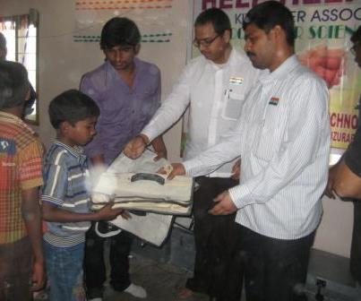
- 26th Jan 2011
“HELP HELPLESS” the team volunteers and staff went to “ Govt Girl Orphange “ conducted games, sports to orphans and distributed prizes for winners, arranged Lunch to them and donated 35 chairs to orphanage.
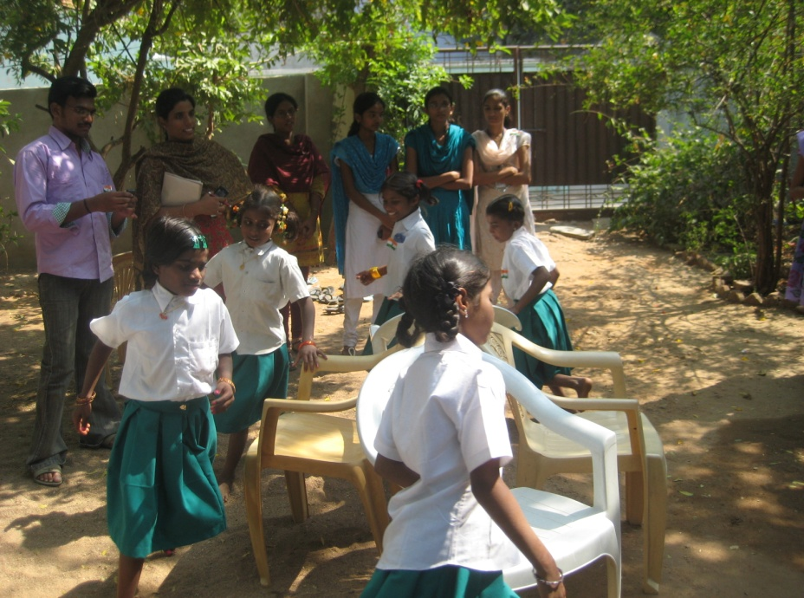
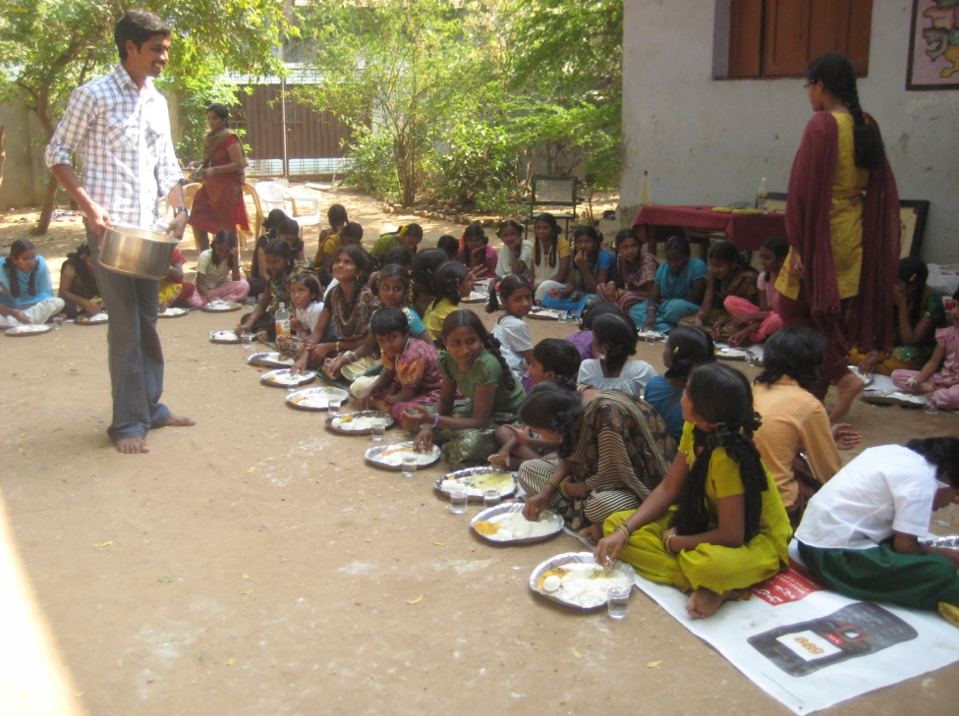
- 4th & 5th Mar 2011
Department conducted a National level two day student technical festival “CloSurE - 11” for all the engineering students of all branches of all colleges.
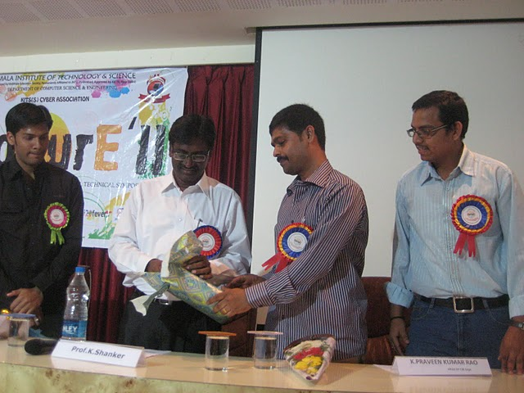
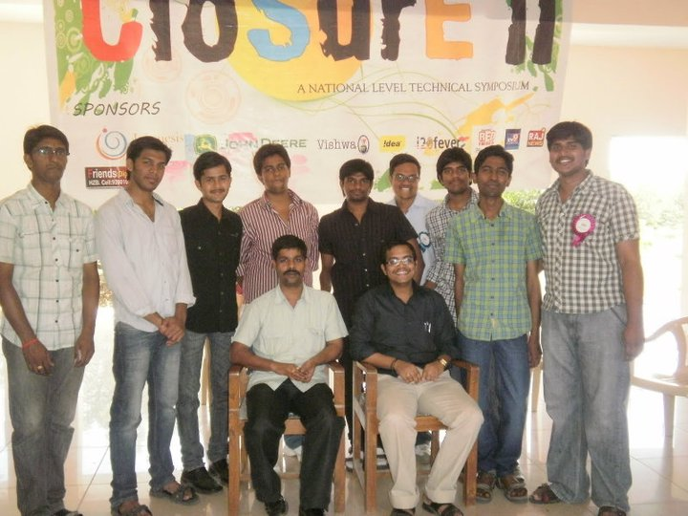
- 15th Aug 2011
“HELP HELPLESS” the team volunteers and staff went to “Spandana Mano Vikasa Kendram “ conducted games, sports to orphans and distributed prizes for winners, arranged Lunch to them and donated 40 chairs & DVD Player to orphanage.
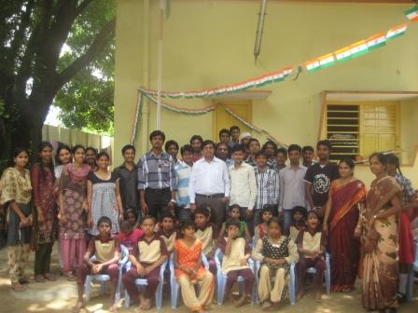
- 26th Jan 2012
“HELP HELPLESS” the team volunteers and staff went to “Govt Girls Orphanage “conducted games, sports to orphans and distributed prizes for winners, arranged Lunch to them and donated 25 chairs, carom boards, chess boards, battery lights & DVD Player to orphanage.
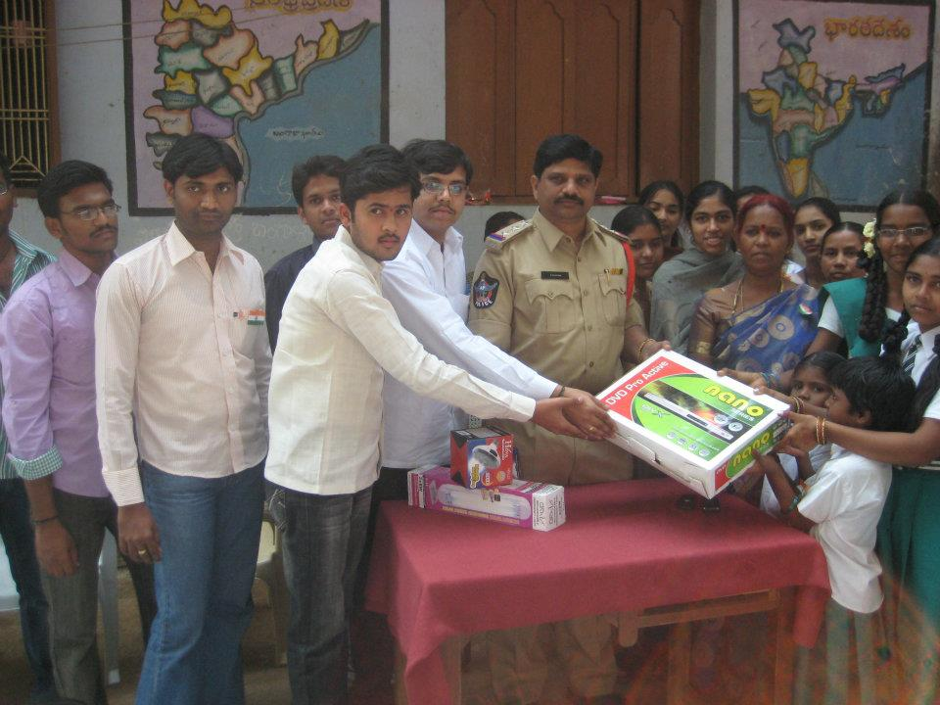
- 18th & 19th Jan 2012
Department conducted a two day workshop on “ANDROID APPLICATION DEVELOPMENT”.
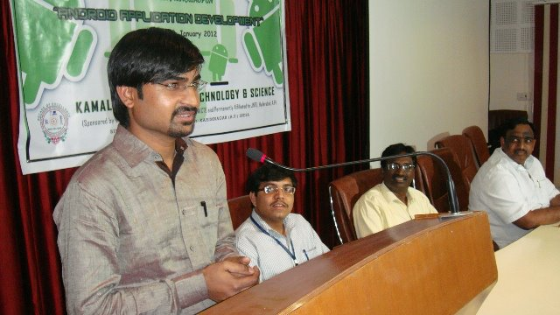
KAMALA INSTITUTE OF TECHNOLOGY & SCIENCE, SINGAPUR – 505 468
DEPARTMENT OF COMPUTER SCIENCE AND ENGINEERING

PROJECTS DONE BY THE STUDENTS AT REPUTED COMPANIES ( OFF CAMPUS )

S. NO | Name & Roll No. of the Student | Project Title | Project done at
1 | M. Archana ( 08281A0594 ) | VOICE BASED AUTOMATIC TRANSPORT SYSTEM | Employee Development Centre, NTPC, Ramagundam
2 | K. Mounika ( 08281A0554 )  B. Srikanth ( 08281A0510 )  L. Raji Reddy ( 08281A0501 )  Y. Anvitha ( 08281A0504 )  P. Avinash ( 08281A0538 ) | IMPLEMENTATION OF PROJECT AND ITS MONITORING | Singareni Collieries Company Limited, Kothagudem, Khammam
3 | N. Jacker Hussian ( 06281A0559 )  A. Bhanu Prakash Reddy ( 06281A0532 )  K. Madhu Pavan ( 06281A0517 )  Tarun Goswami ( 06281A0550 )  Ch. Purushotham Reddy ( 06281A0537 ) | TEXT TO TEXT STEGANOGRAPHY | Wireless & Communications Research Pvt. Ltd, Hyderabad

KAMALA INSTITUTE OF TECHNOLOGY & SCIENCE, SINGAPUR – 505 468
DEPARTMENT OF COMPUTER SCIENCE AND ENGINEERING

EXPERT LECTURES ORGANIZED

- 7th Jan 2009
With help of “NIRMAAN” organization department arranged “SWAMI VIVEKANANDA’S YUVA SANKALP” program, the member of that organization gave a speech on swami VIVEKANADA, distributed the VIVEKNANDA’s books to all the students of all the departments of the college.
- 29th Jan 2009
Department arranged a seminar for the students who want to study in Canada. Uma Venkatraman, Director & Immigration Advisor, CSIC and Venky Subramaniam, Director-OSSS gave useful information about studies and opportunities in CANADA.
- 17th & 18th Feb 2009
Department arranged two day workshop on “SOFTWARE TESTING” for the students. Prof M.L.SAI KUMAR, IPE-INDIA gave the lectures.
- 18th Feb 2009
M.L.SAI KUMAR, IPE-INDIA gave a seminar for the teaching faculty on the topic “Teaching Methodologies and techniques”.
- 18th & 19th Jan 2012
Department conducted a two day workshop on “ANDROID APPLICATION DEVELOPMENT”.

